Information Architecture vs. Navigation: the keyhole problem

To a first approximation, the navigation of a website refers to the interface that helps users browse effectively and find their way around, whereas information architecture refers to the category system that classifies the content of a site and supports search. The two are closely related, indeed typically confounded, because navigation on smallish sites is just a restatement of information architecture. But on large sites, or sites where pages are dynamically created out of multiple contents, it is not possible to create a navigational system that mirrors architecture. In such sites the desiderata for good navigation and good IA are different. Each is concerned with a different formal problem and their solutions pull apart.

The formal problem of navigation is to provide a user with the signposts and visual cues to find the particular information they are looking for (or the information the site managers want them to find) from within a large information collection. This resembles is like the ‘keyhole’ problem shown in figure one.

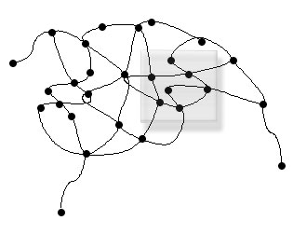
Given a formal structure and a window in which you can see at most n neighbors find the maximally effective display

